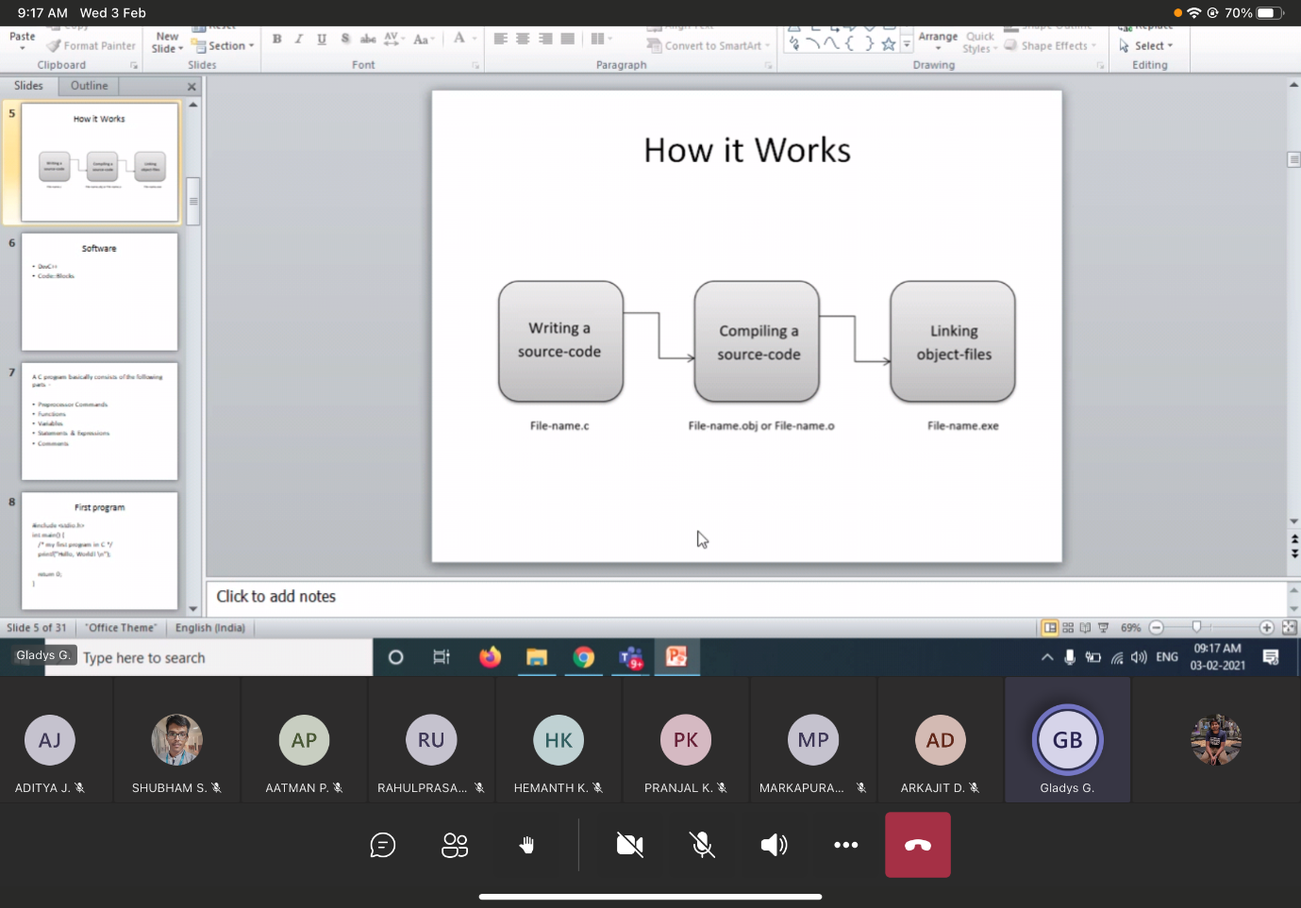

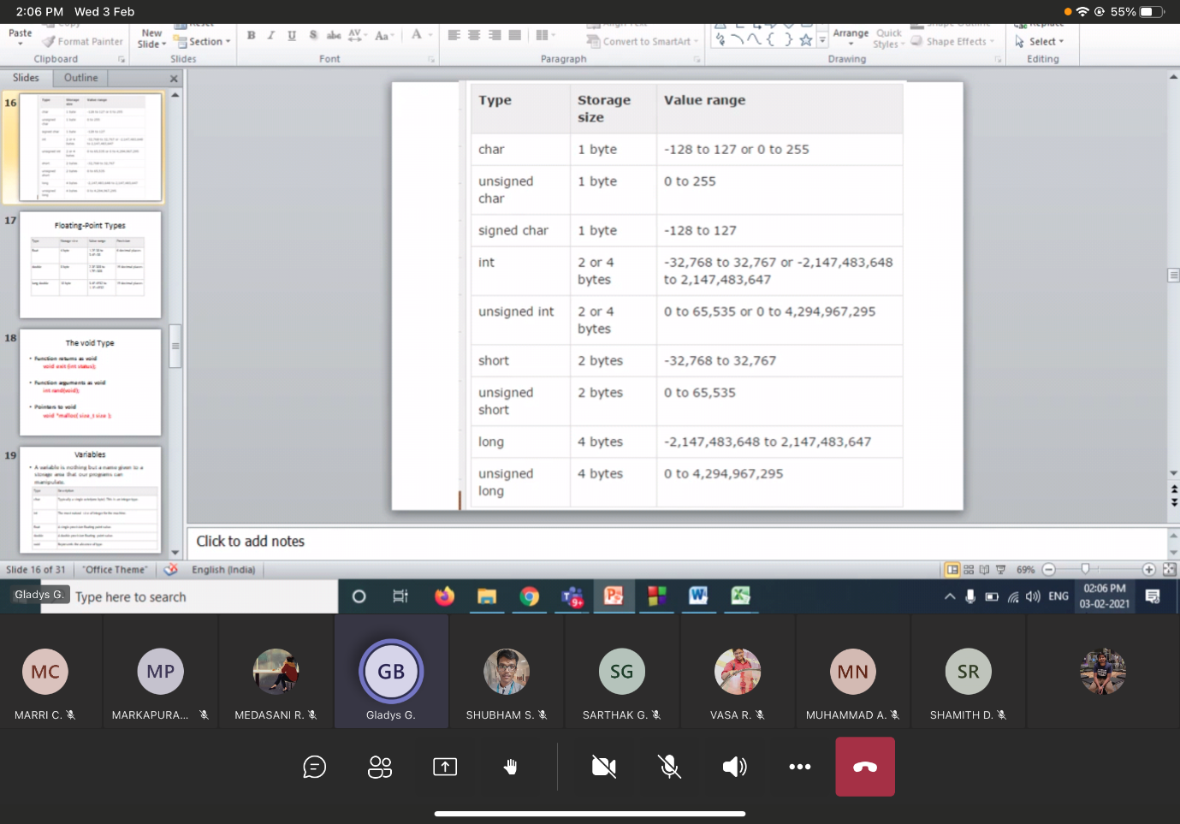

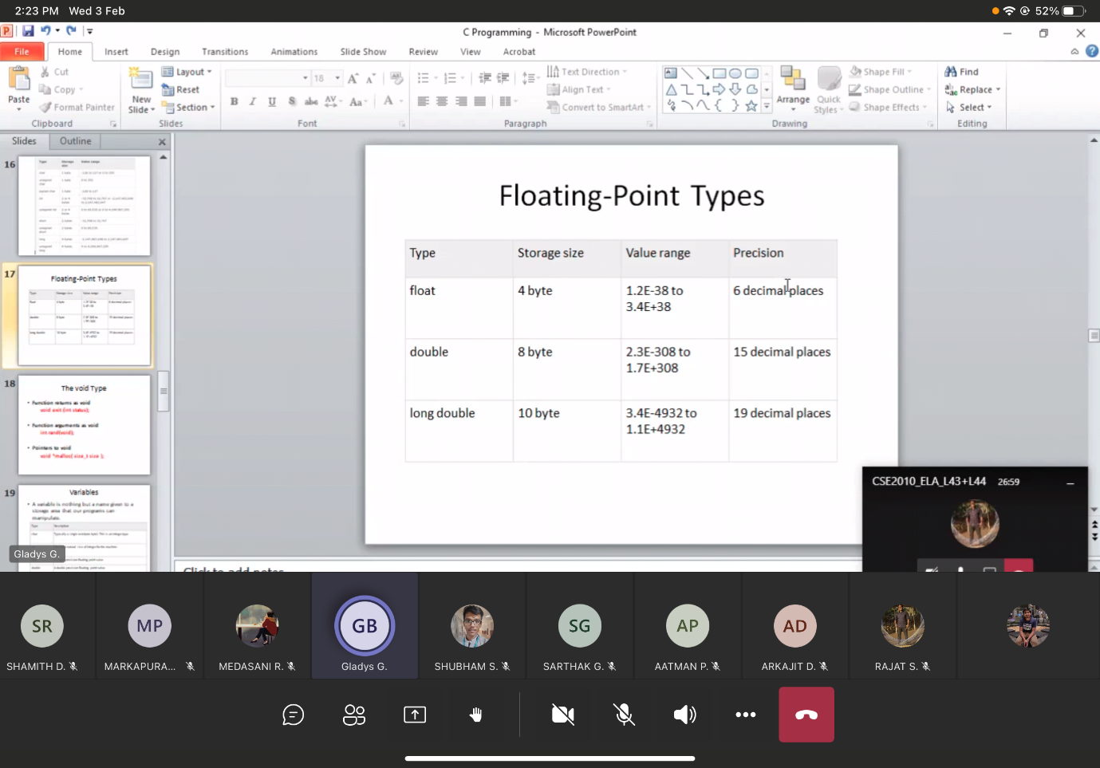

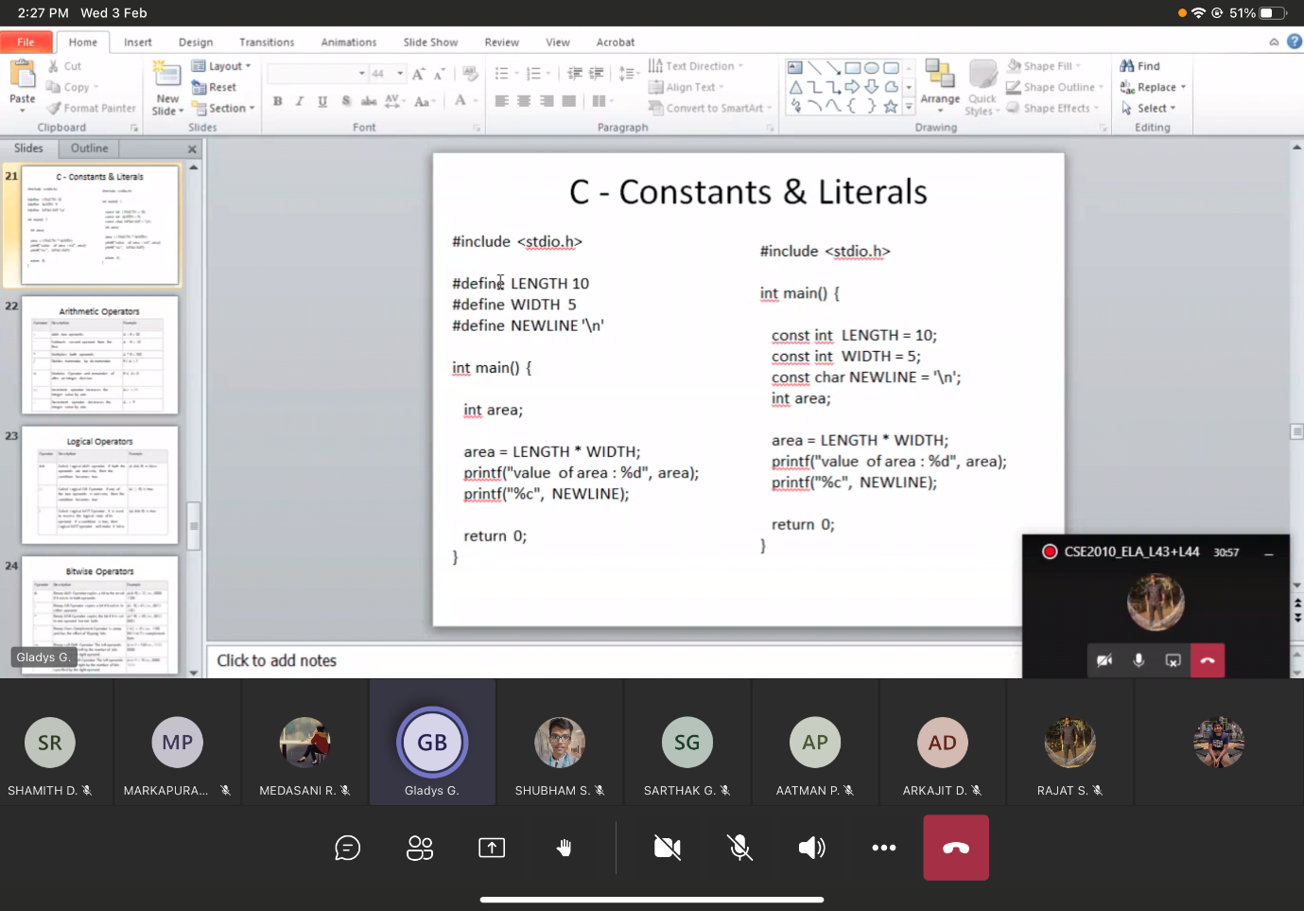

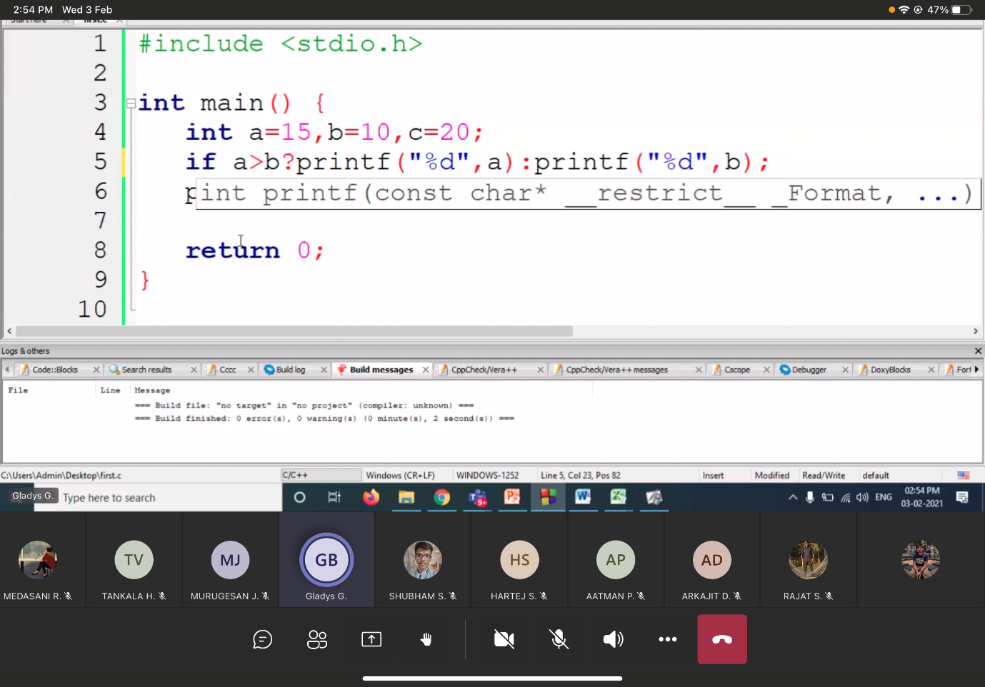

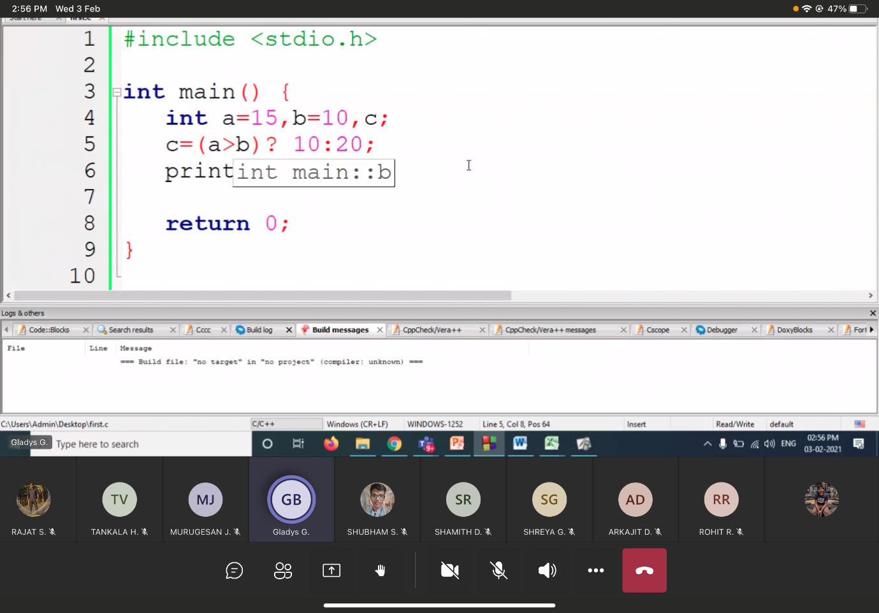

**15/2/21**

Call by value 🡪  
Call by reference 🡪 swaping two number

Module-2

Slide 🡪 12/14 Data’s un initialized  
 Data’s initialized 🡪

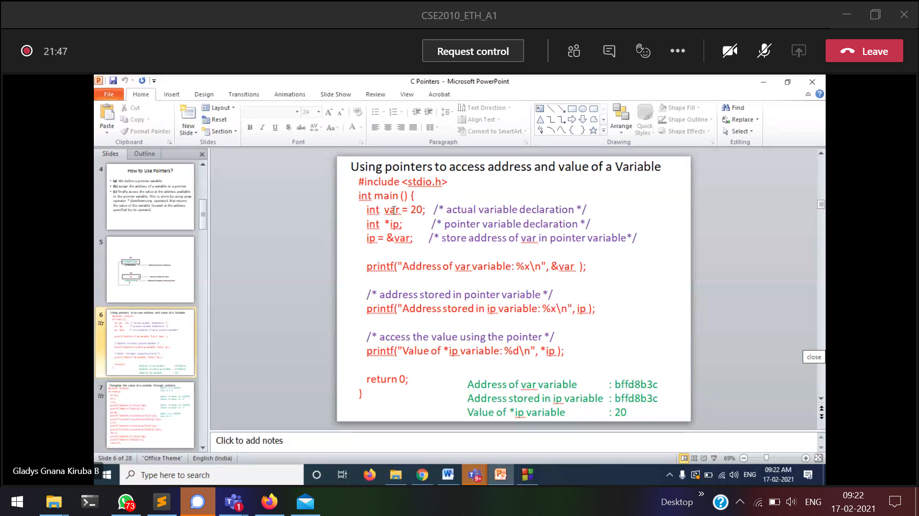  
%x 🡪 hexadecimal format

22/2/2021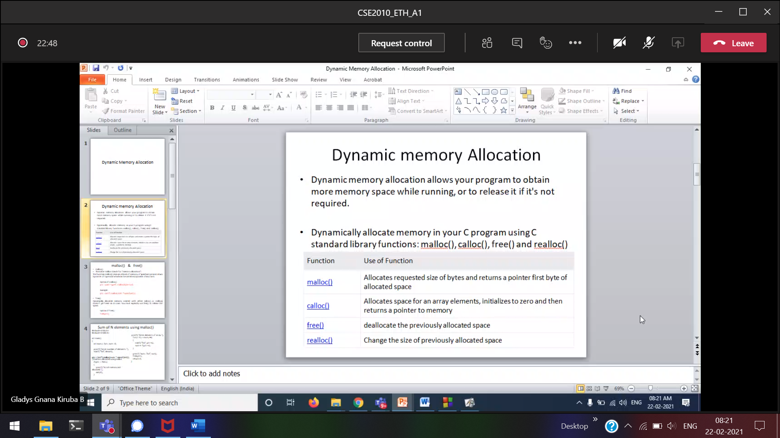

Memory will be created only during Run-time.  
That memory will be created in the heap-area.  
#include<stdlib.h>

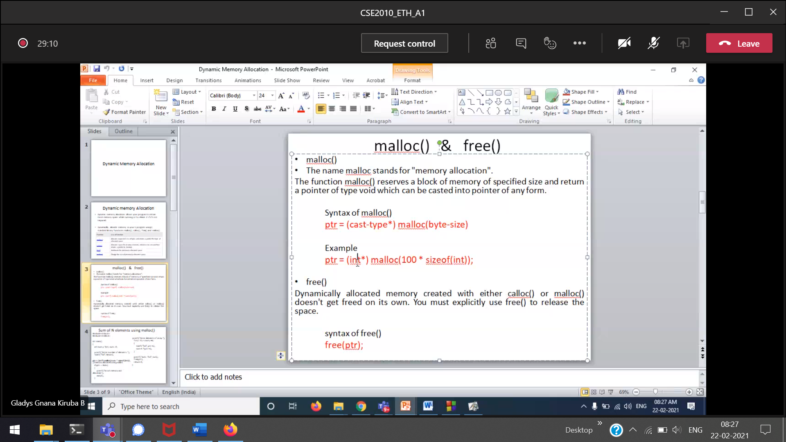  
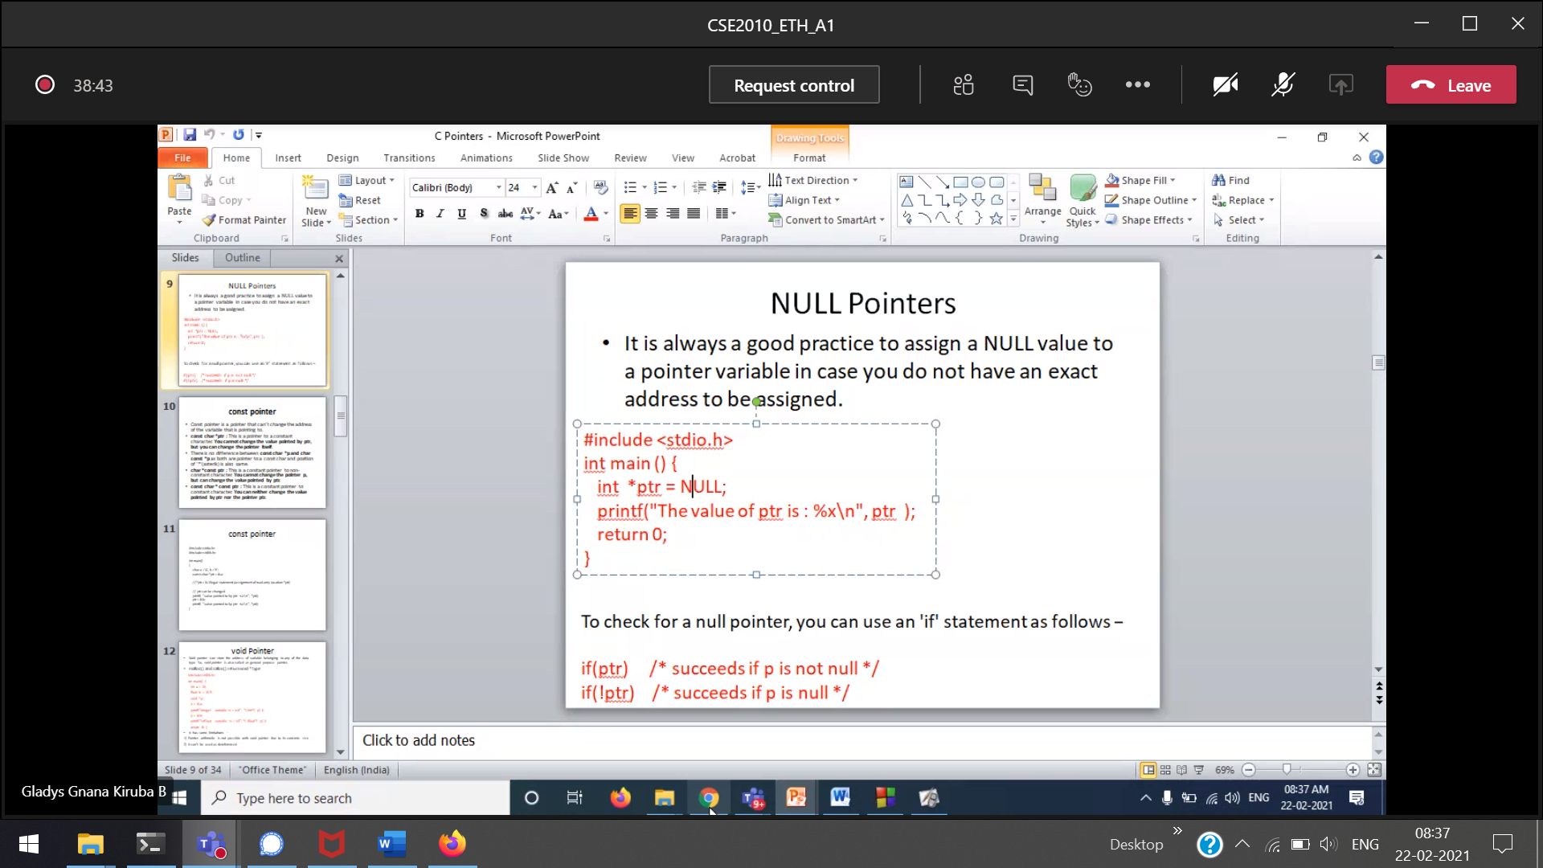

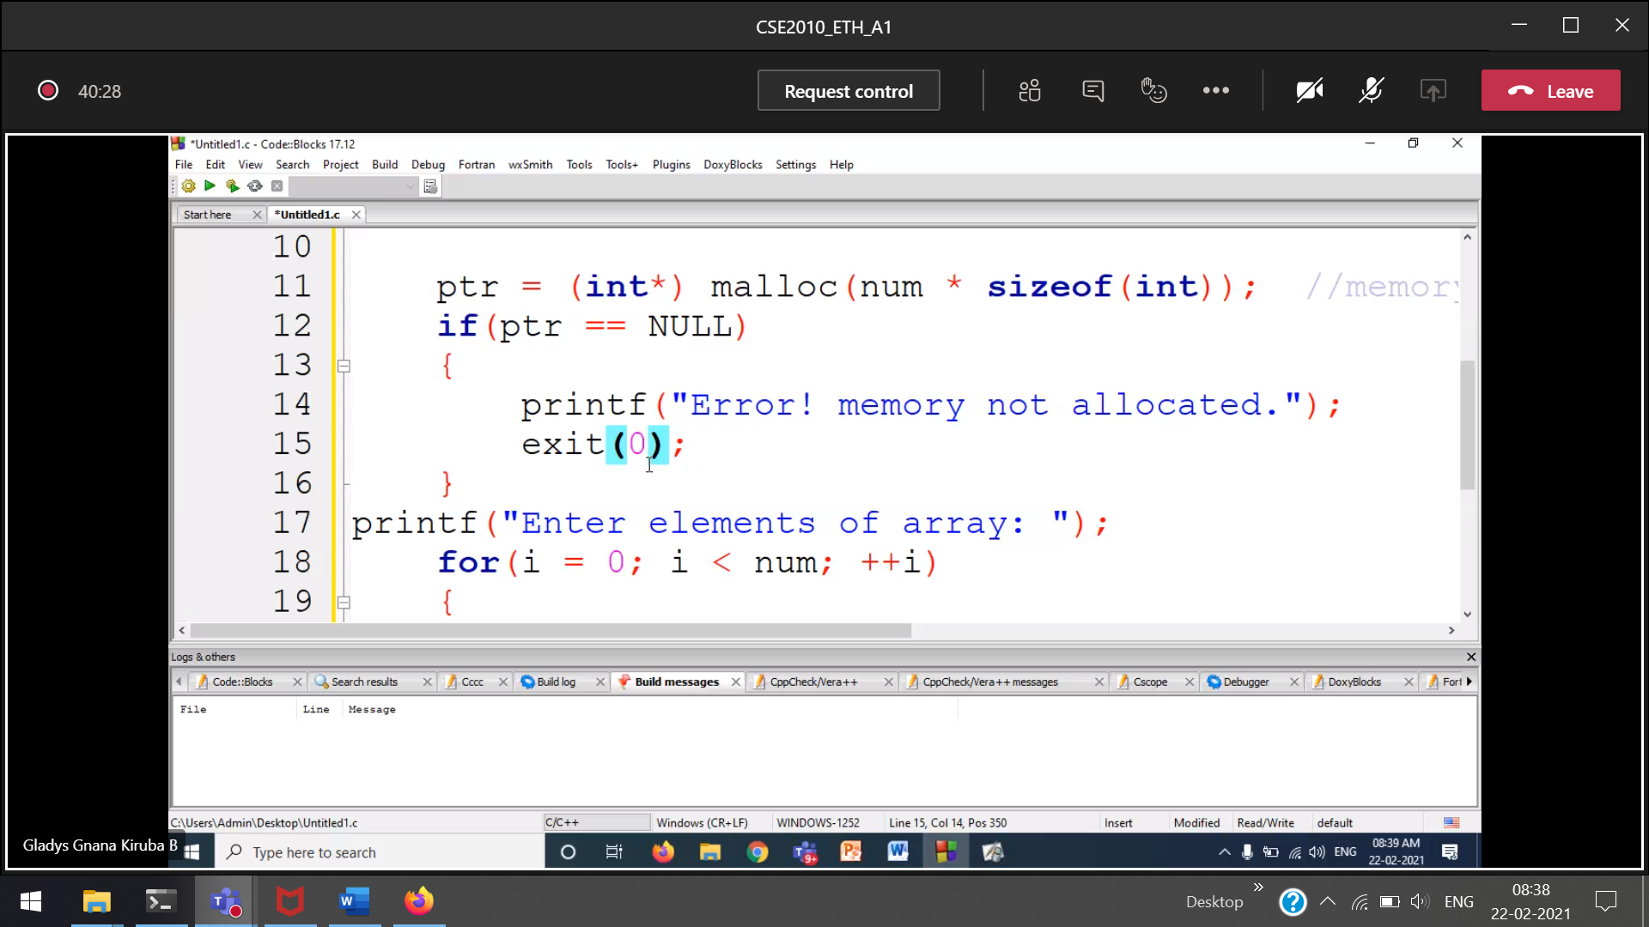

exit(0) 🡪 without error  
exit(1) 🡪 with error  
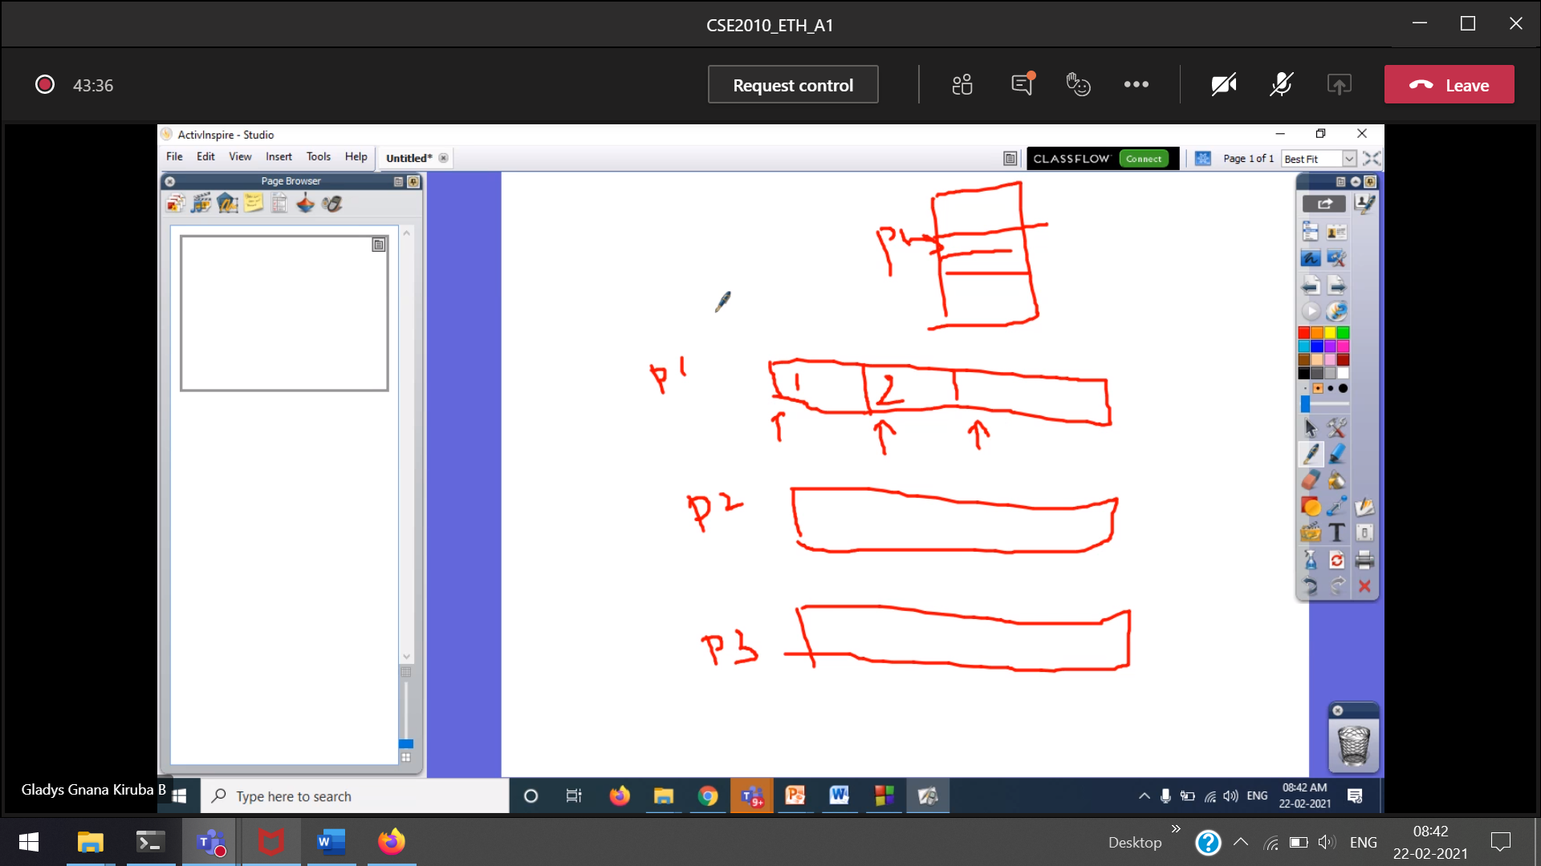  
(ptr+i) 🡪 leaves 4 bytes for every number



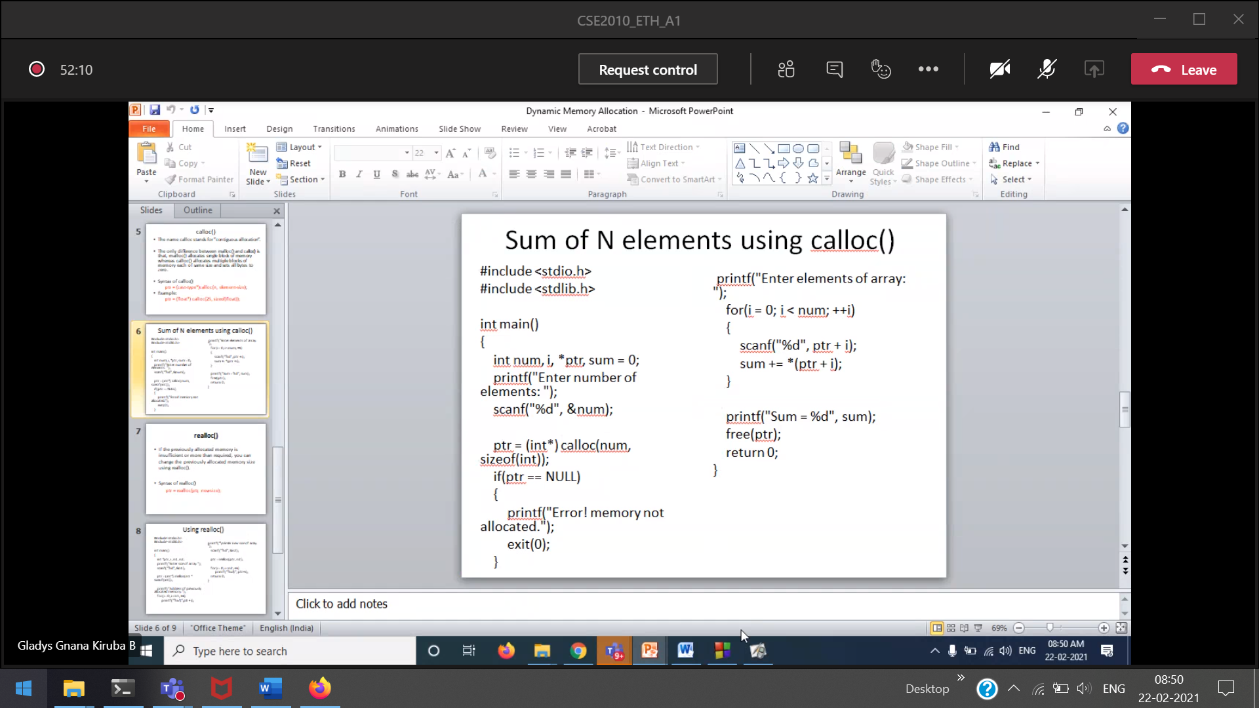  
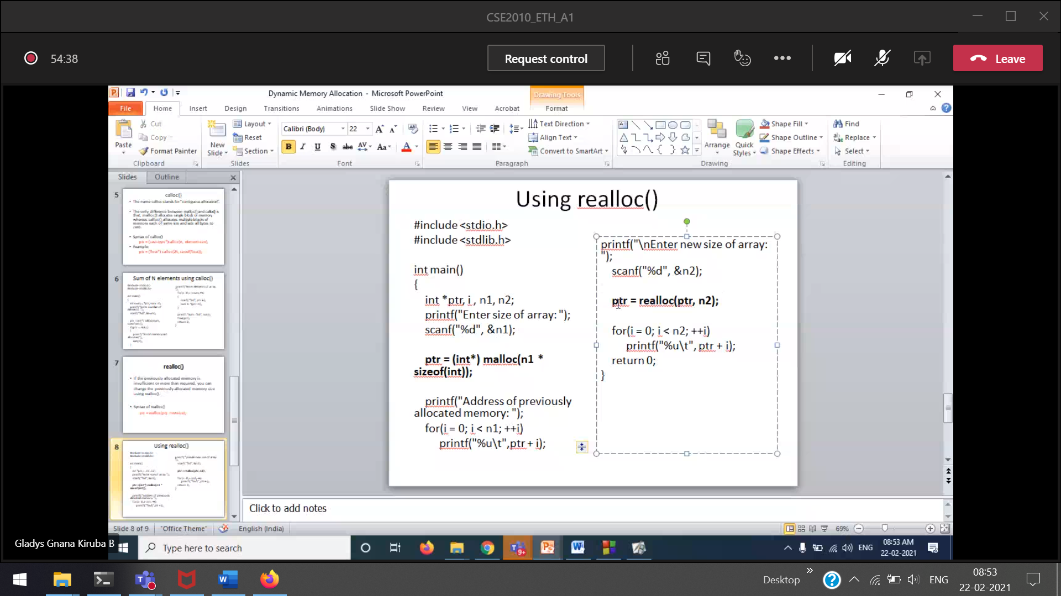

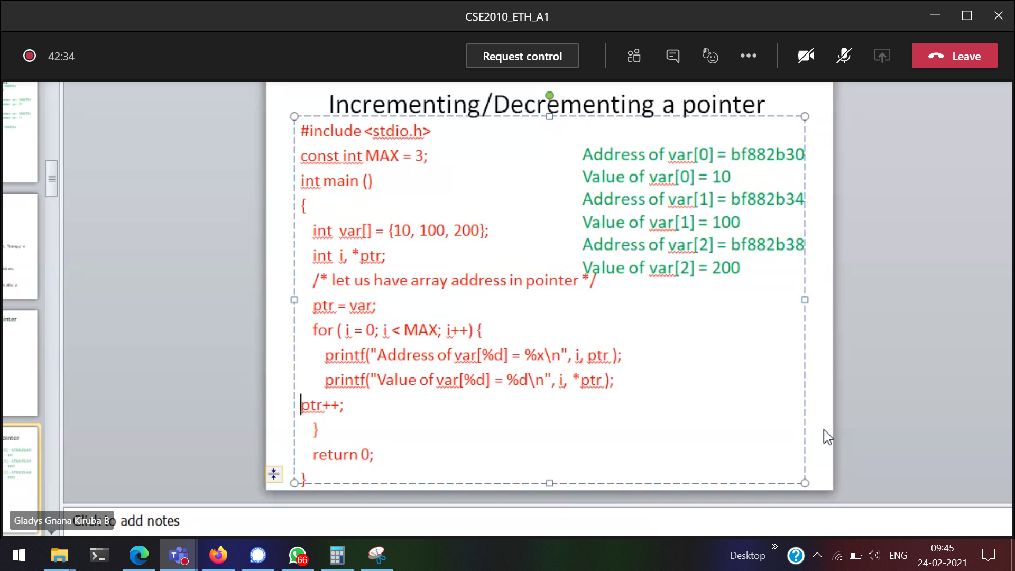

We cannot make the ptr to go to the last element of the array. And print the reverse of the array elements.

*ptr++ 🡪 precedence is ++, then only *.  
So ptr will move to the next element, and then print the value stored in *ptr

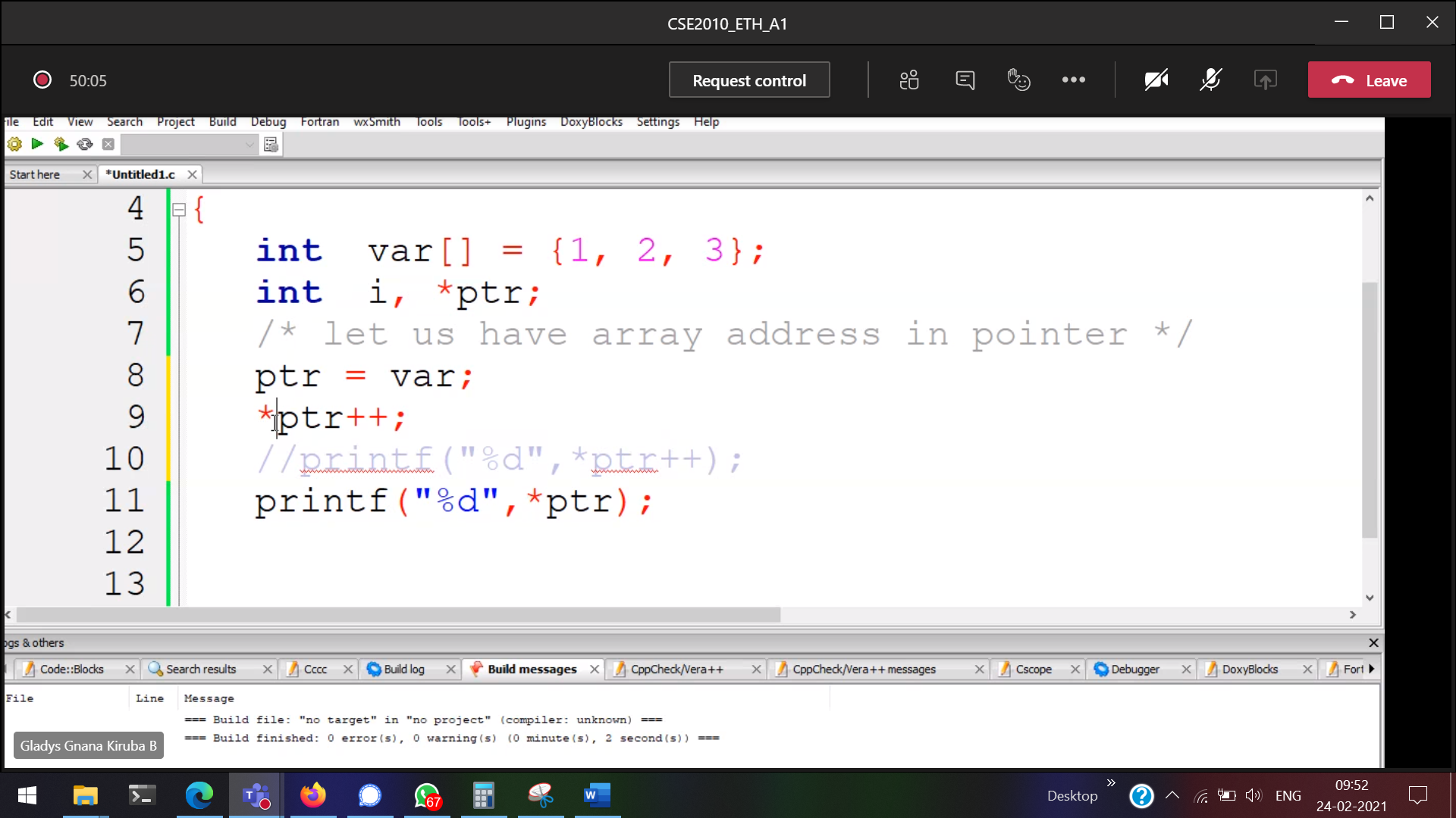  
Output 🡪 2

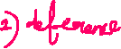

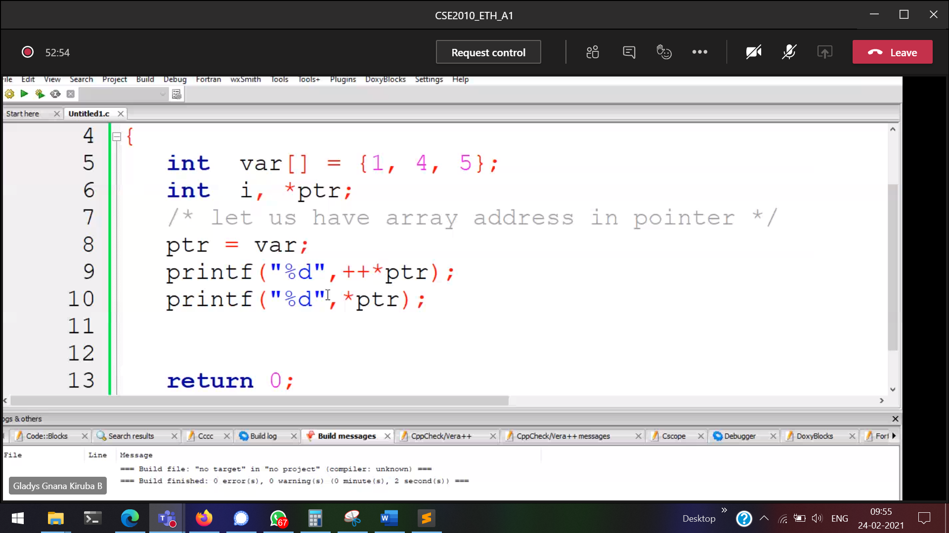

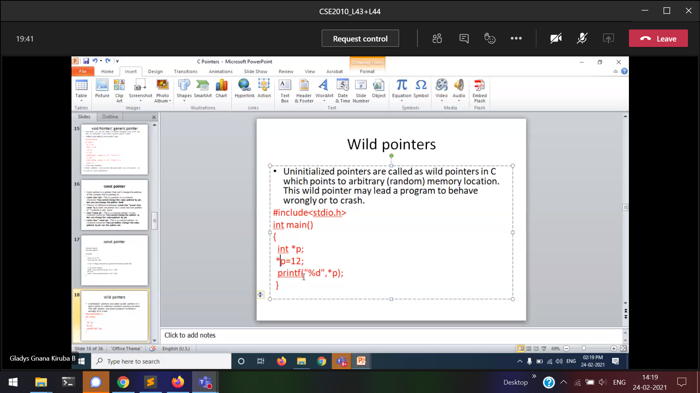

If the pointer is not pointing to any memory 🡪 wild pointer

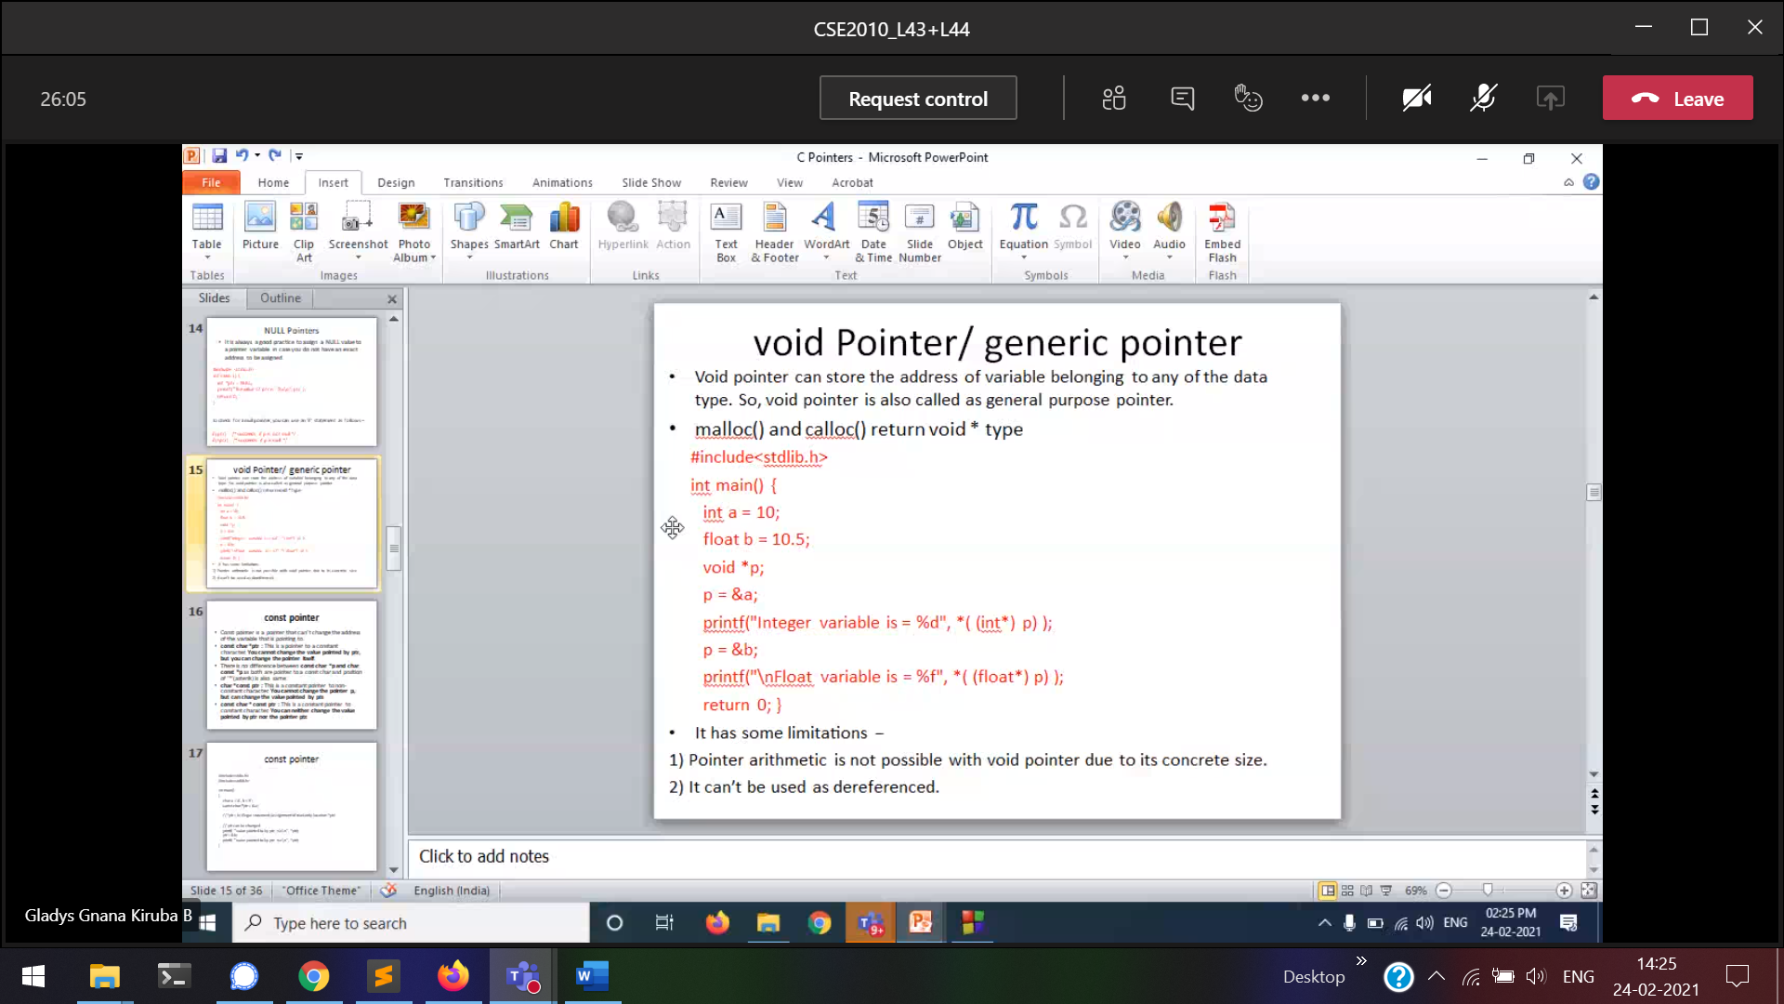



Typecasting is essential.

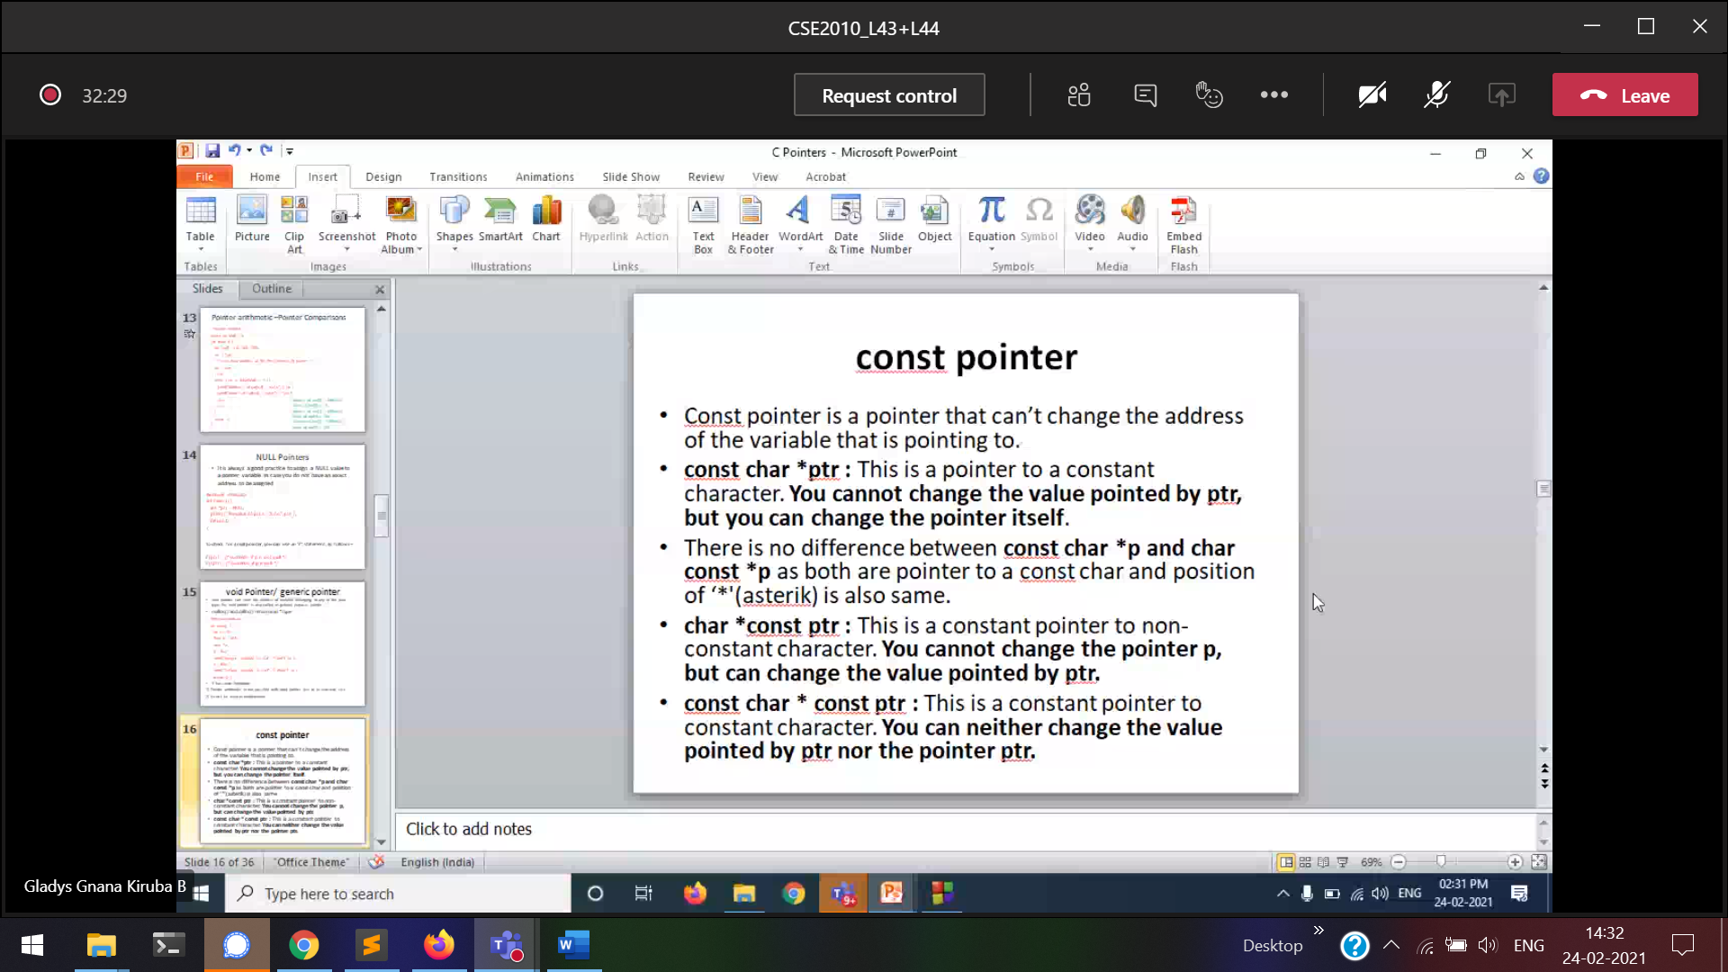



***const char *ptr***  
*ptr(i.e value) cannot be changed. But ptr itself can change(can point to any variable)  
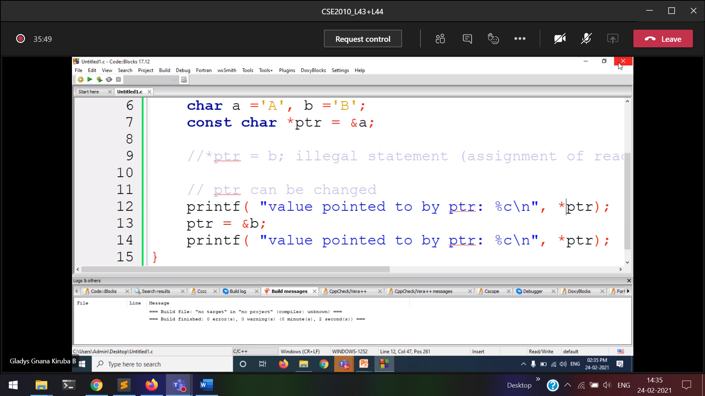

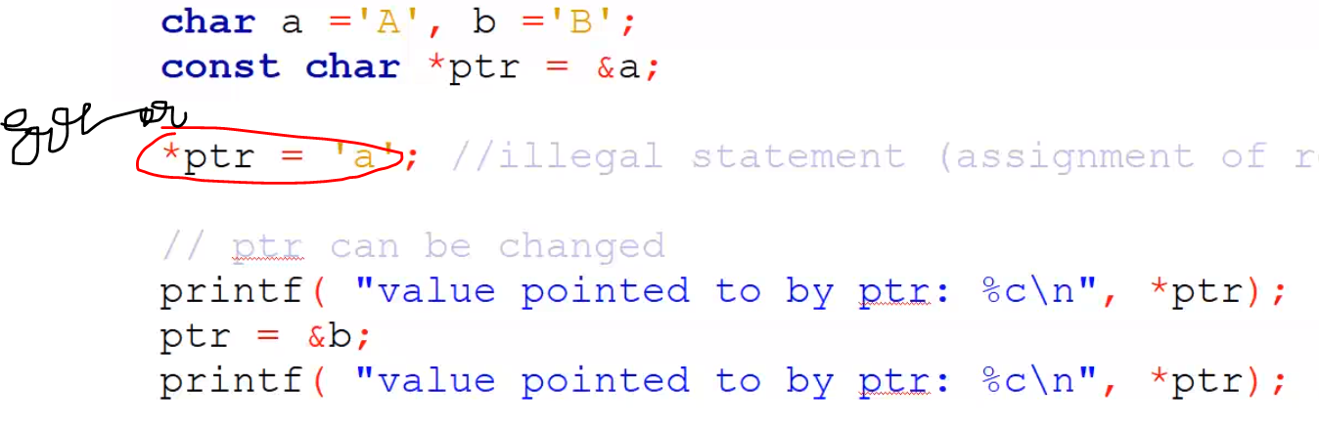

***char* const ptr***

*ptr(i.e value) can be changed. But ptr itself cannot change(cannot point to any variable)

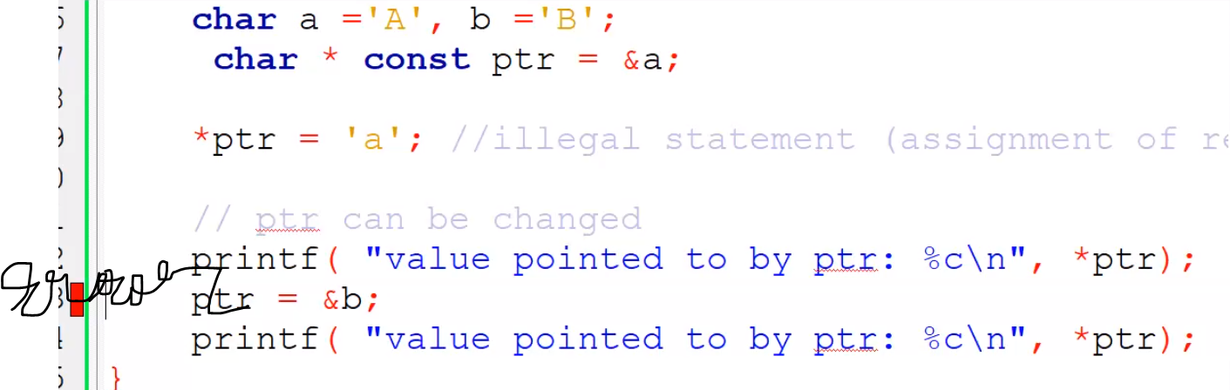

***const char* const ptr*Cannot change the value and pointing variable also**

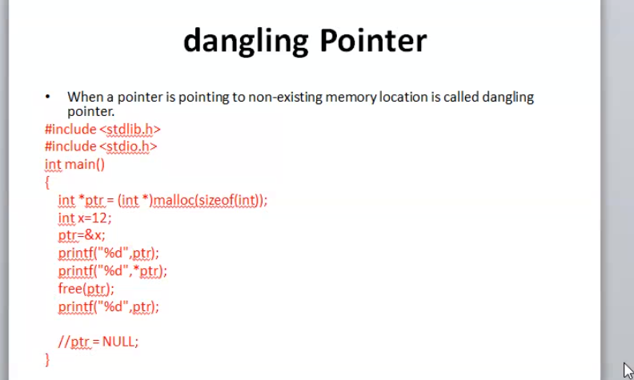



Segmentation fault. Core dumped

Will give some garbage values.  
In array 🡪 like out of the memory.

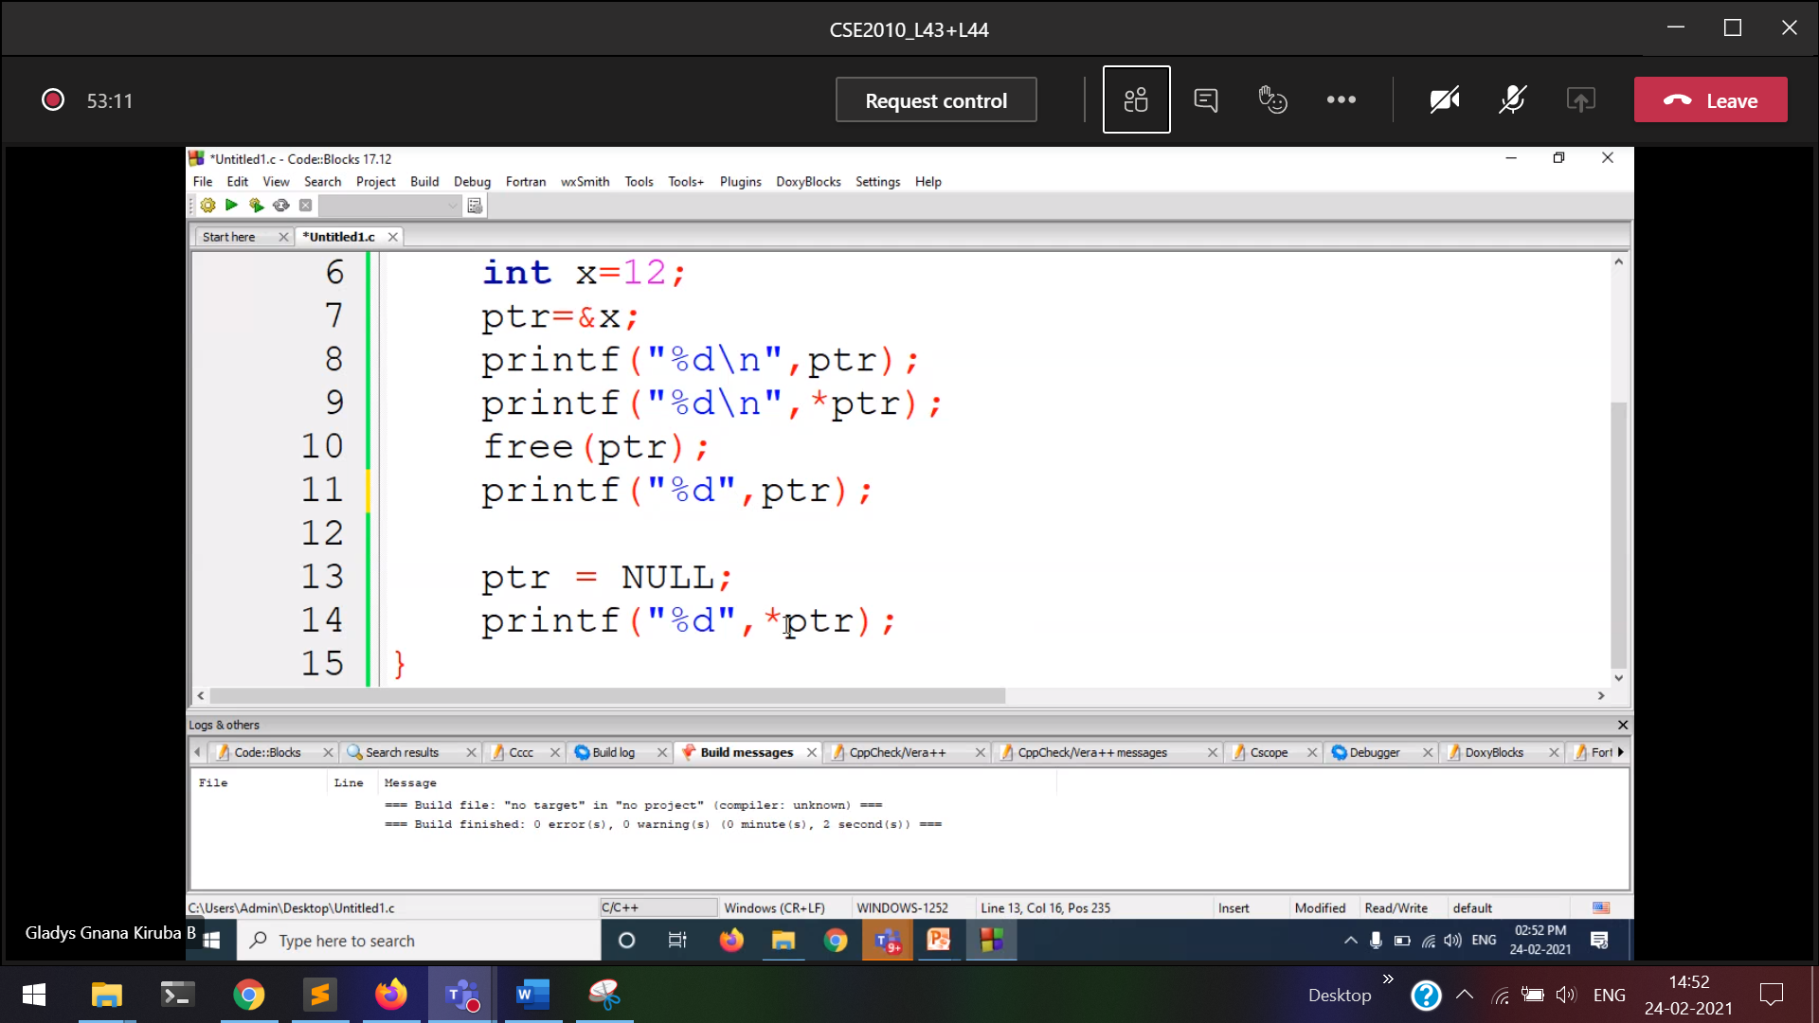

To avoid dangling pointer, we are using null pointer.

1/3/2021

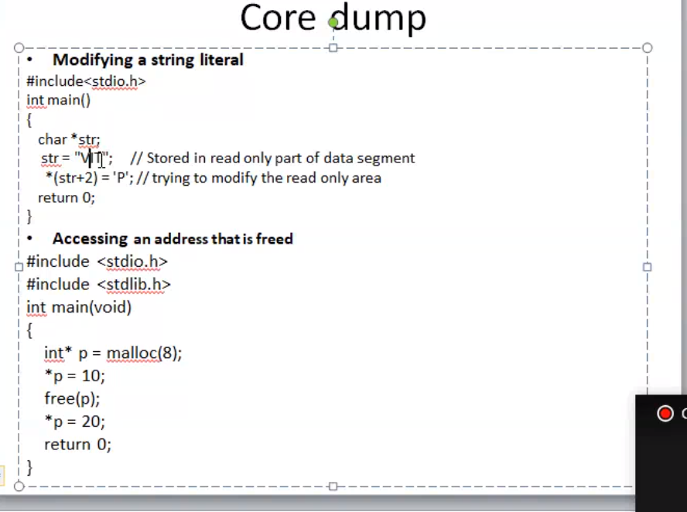

str 🡪 cannot be changed.  
*str 🡪 can be changed

Since str 🡪 is only in read only part.

In an array of characters, it can be changed   
But str itself a single string 🡪 it cannot be changed

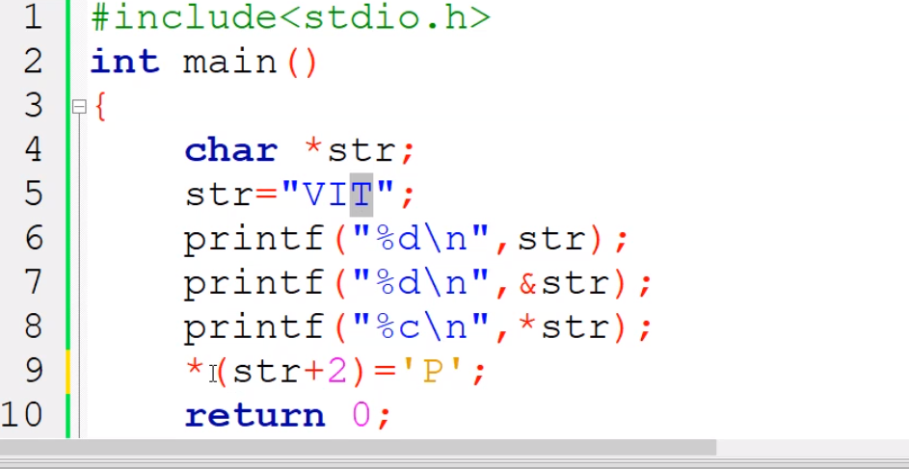

Changing t to P

3/3/2021

Arrays and pointers

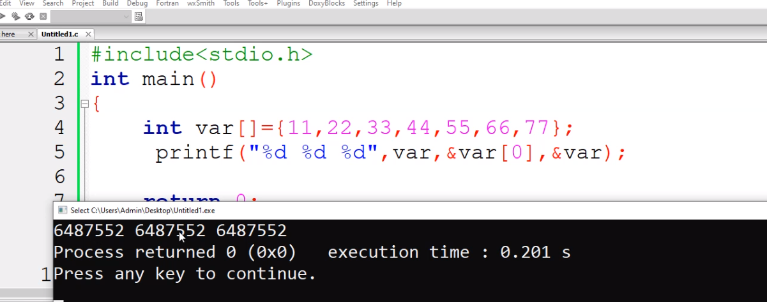

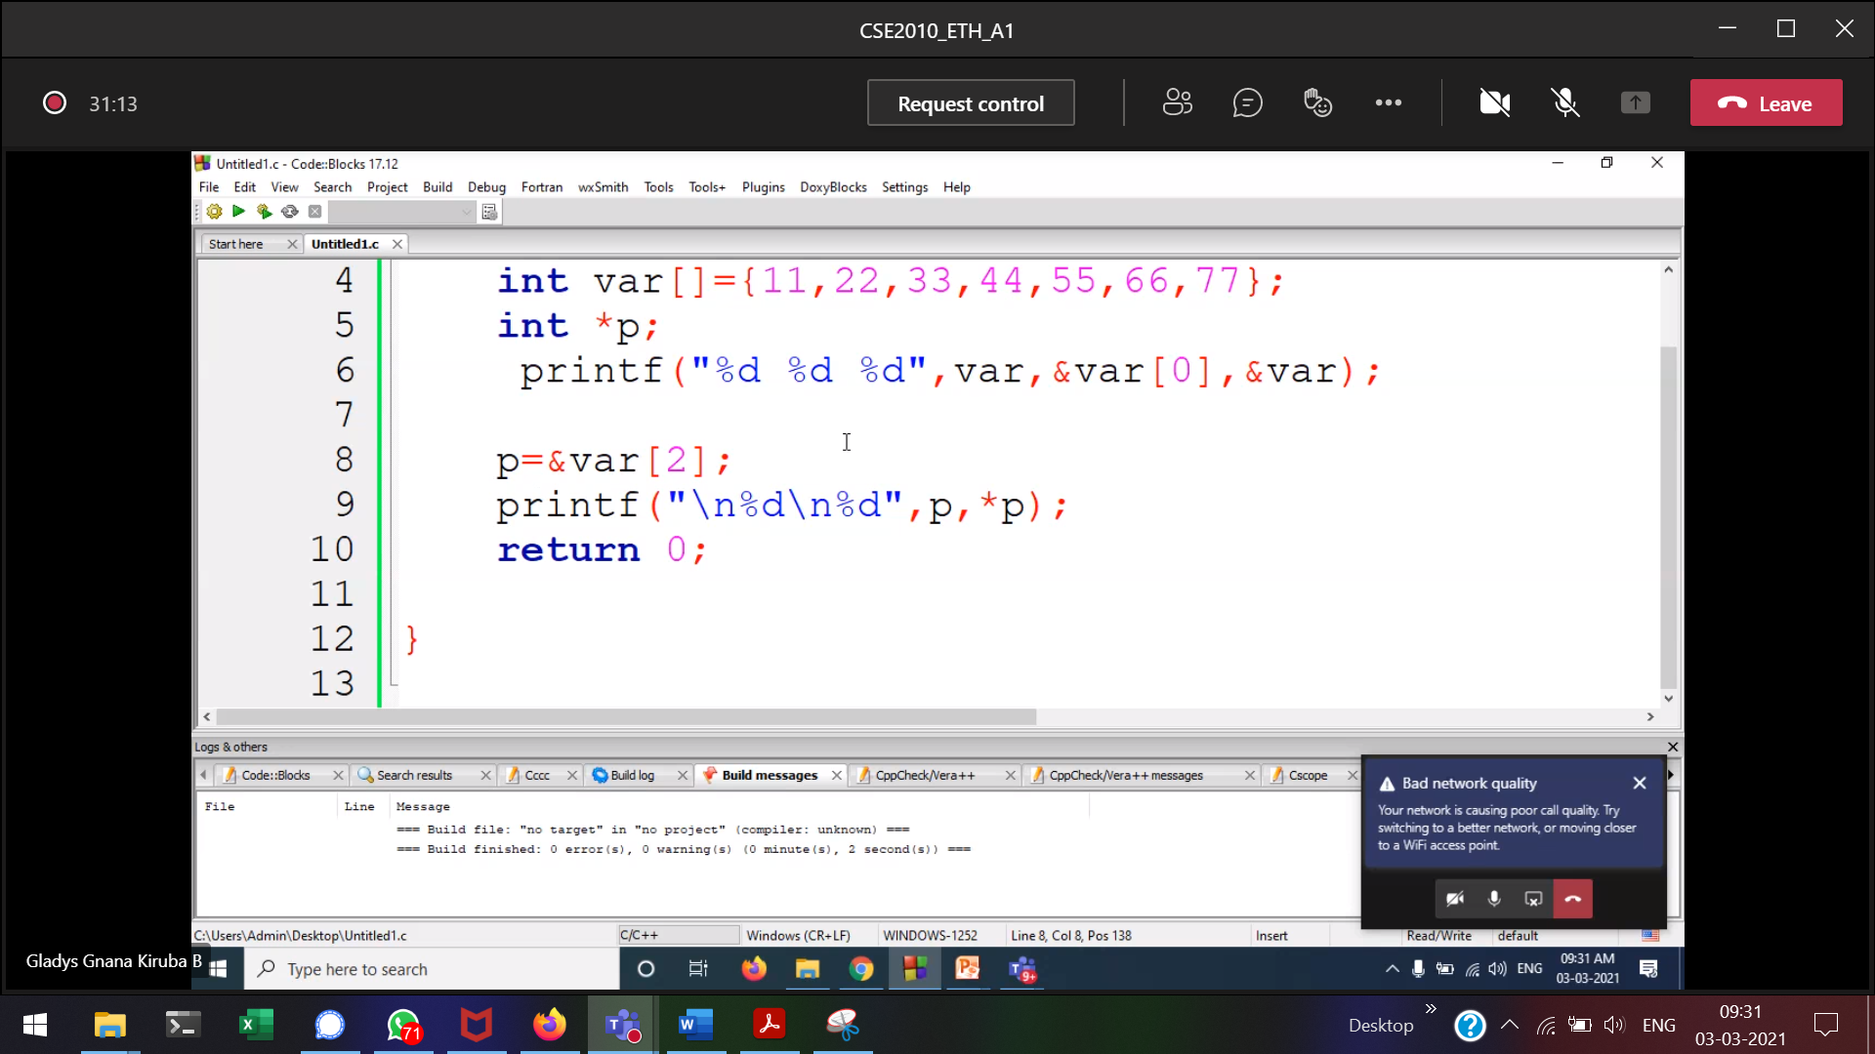

Accessing individual elements should be array though pointer

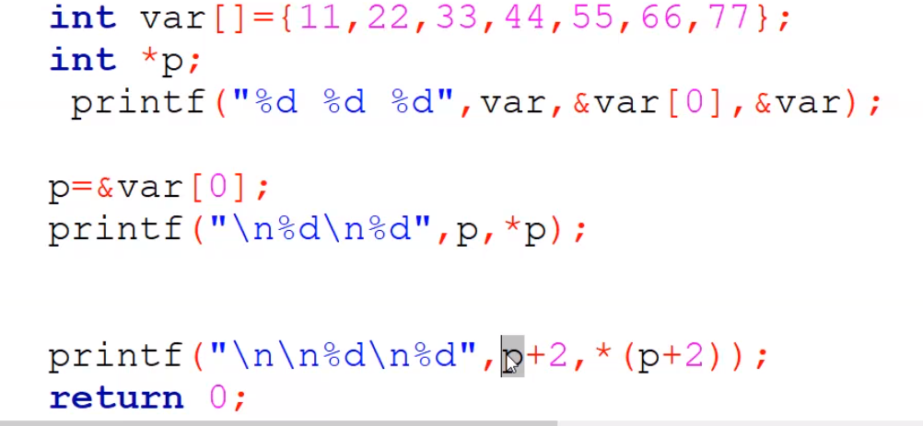

Accessing through pointers

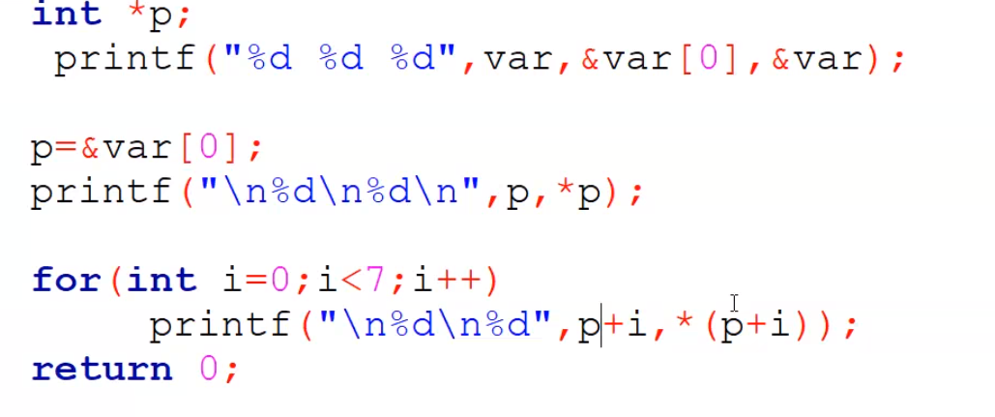

**The below one is the optimal solution**

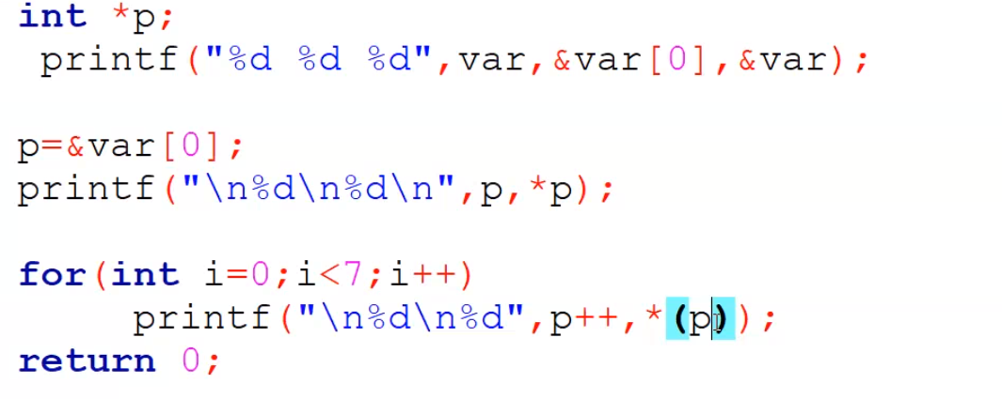

Sort an array based on pointers  
access the array elements using pointers, not using only index.

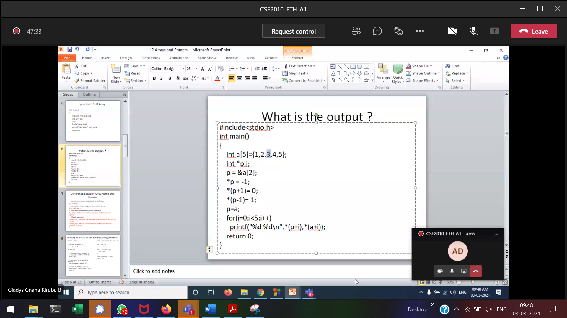

Pointer is not moving at all.(ptr = ptr + 1)  
Only while incrementing, the pointer will move (ptr++)  
Ans 🡪 11-105

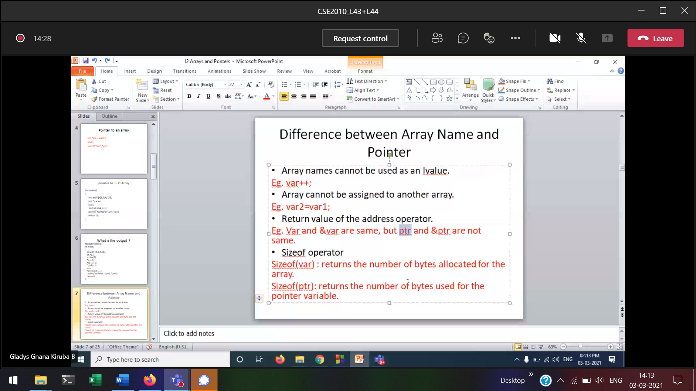

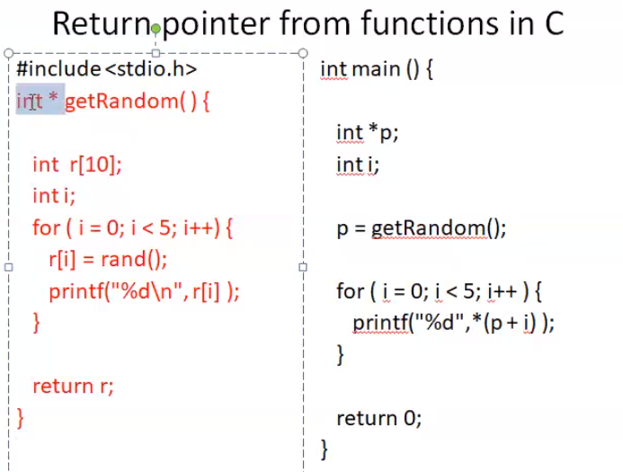



Returning the pointer

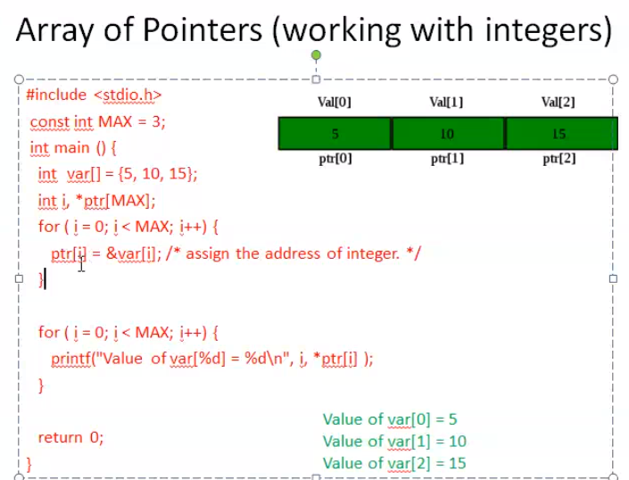

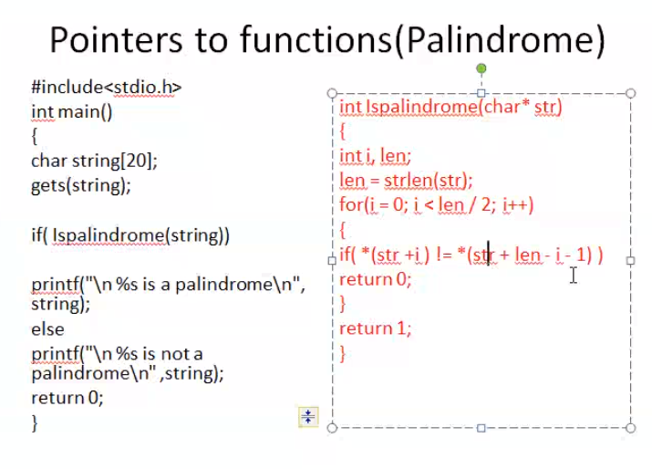

1. *p
2. (*ptr)[5] 🡪 **[is a pointer to an array of 5 ints].** Holds only 1 address at a time.  
   will not go to the individual elements of an array. Will jump from *ptr[0]🡪arr1[5] to another *ptr[1] 🡪 arr2[5].  
   It will make 5 pointers pointing to 5 elements of array respectively  
   So we can't access the second value in array using first pointer with increment

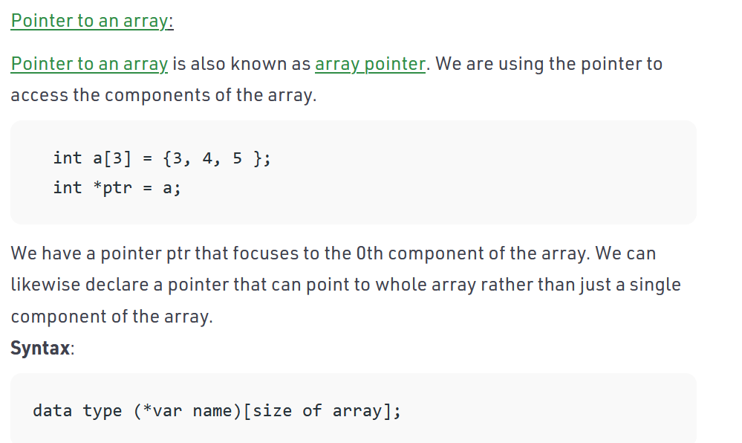

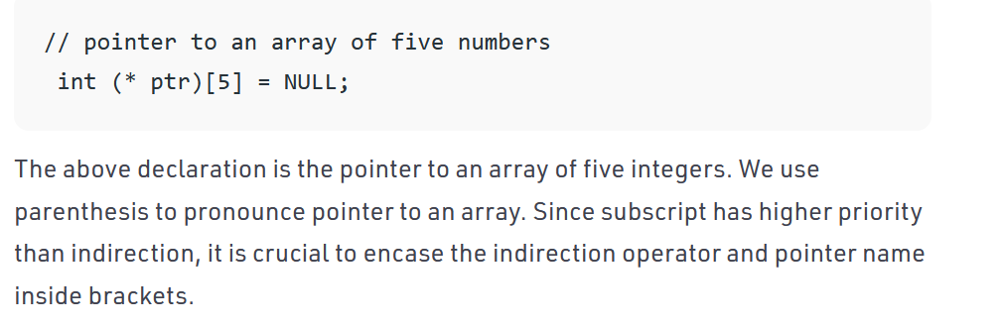

1. *ip[5]; 🡪**[is an array of 5 pointers.]**Holds the address of 5 individual array element at a time.ip[0] 🡪 1st element in arr1  
   ip[1] 🡪 2nd element in arr1  
   ip[2] 🡪 3rd element in arr1

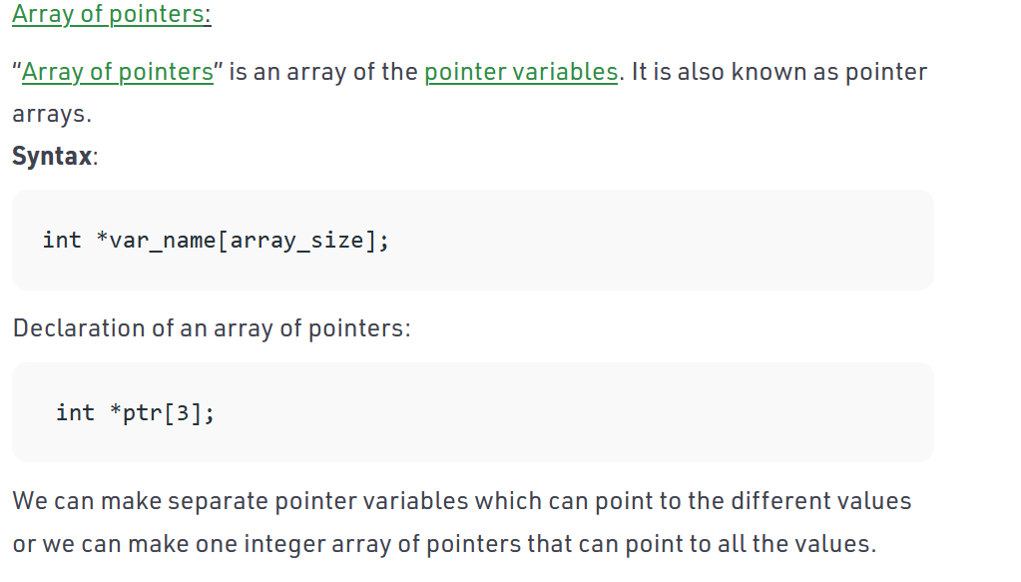

Eg: (*ptr)[2];  
arr1[100] = {1,2,…100}  
Will jump twice each time

C pattern...  
1. 1st module full except structures  
2. 2nd module full except 2d pt array  
3.All programs may be 3x10 or   
6x5  
4.sets irukku